8
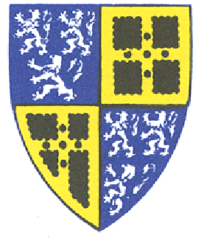
Town of Old Saybrook
Public Health Nursing Board
Town Hall, 302 Main Street,
Old Saybrook, CT 06475
_______________________________________________
Annual Meeting Agenda
6:30pm, Tuesday, December 6, 2022
302 Main Street, Old Saybrook
Second Floor Conference Room
Via phone: (929) 436-2866 Meeting
Via internet click this link
ID: 933 5220 5842
- Call to order and roll call
- Audience of citizens
- Review and approval of minutes
- Review and approval of treasurer’s report
- Correspondence report
- Old Business report
  - Update ARPA Application
- New Business Report
  - Clerk time & task invoice approval
  - FY 2024/25 Budget Discussion and Approval
  - Election of Officers
  - PHNB Meeting Schedule for January -May 2023
- Y&FS Representative Report
- Flanagan Fund Report
- Nightingale Fund Report
  - Update 2023 Nightingale Scholarship Letter (add quote)
  - Review/Discuss Nightingale Scholarship press release, information to schools, copying letter.
- Morris Fund Report
- Adjournment
NEXT REGULAR MEETING
Tuesday, January 3, 2023 at 6:30pm
Via internet click this link
Via phone: (929) 436-2866
Meeting ID: 933 5220 5842

